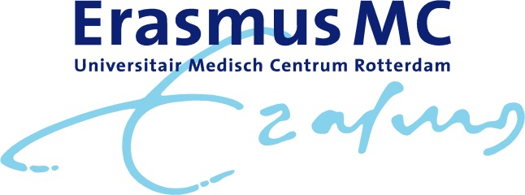
Program Symposium High Precision Radiotherapy on the occasion of the inauguration of prof. dr. M. S. Hoogeman
December 14th 2018
Location: Het Nieuwe Instituut, Museumpark 25, 3015 CB Rotterdam

09.30-10.00h Welcome with coffee
Moderator: prof. dr. B. Heijmen, medical physics, Erasmus MC Rotterdam
10.00-10.05h Opening by prof. dr. P. Sonneveld, acting head of Department of Radiotherapy Erasmus MC Rotterdam
10.05-10.35h Molecular Radiomics by Imaging Mass Spectroscopy for visualizing intra-tumor heterogeneity: correlation with clinical outcome parameters by prof. dr. ir. B.P.F. Lelieveldt , LUMC Leiden
10.35-10.40h Discussion
10.40-11.10h Biological Image Guided Radiotherapy by dr. S. Petit, Erasmus MC Rotterdam
11.10-11.15h Discussion
11.15-11.45h Automation in radiotherapy – successes, challenges and future by prof. dr. B. Heijmen, Erasmus MC Rotterdam
11.45-11.50h Discussion
11.50-12.20h Valuation of Proton Therapy in the Netherlands by prof. dr. M. van Vulpen, head of HollandPTC, Delft
12.20-12.25h Discussion
12.25-13.30h Lunch
Moderator: prof. dr. M. van Vulpen, head of HollandPTC, Delft
13.30-14.00h Artificial intelligence – opportunities for radiotherapy by prof. dr. ir. A.L.A.J. Dekker, Maastro Maastricht
14.00-14.30h Robust Proton Therapy by dr. Z. Perko, Delft University of Technology
14.30-14.35h Discussion
14.35-15.05h High Precision Radiotherapy; what should we be aiming for? By prof. dr. S. Senan, VUmc Amsterdam
15.05h Departure to Erasmus University, Burgemeester Oudlaan 50, 3062 PA Rotterdam
16.00h Inauguration of prof. dr. M. S. Hoogeman

